Name ______________________________________
Homework Paper #4
Due ____________

Reading Comprehension
There are Five Steps to Success for any reading passages:
1. Read the title, author, and any headings.
2. Read the first two questions.
3. Read and interact with the selection.
4. Ask yourself, “What was the main idea and the author’s purpose?”
5. Answer the questions using process of elimination.
Read the passage and answer the questions that follow.
Who Discovered America?
by Anonymous
¶ In the United States, October 12 is Columbus Day, commemorating the day that Christopher Columbus discovered America. However, many historians now believe that another European discovered North American nearly 500 years before Columbus.
Leif Erikson was the son of Erik the Red, a Norwegian adventurer who moved to Iceland. When he was exiled from Iceland, Erik the Red bought a boat to search for new land. He found a huge, ice-covered island that he named Greenland to encourage settlers to come.
Leif Erikson grew up listening to stories about a land that lay to the west of Greenland. In about 1000 AD, Erikson and a small crew sailed in search for this new land. When he and his men reached North America, they found fertile soil, rivers teeming with fish, and thick forests. Erikson was so delighted that he named the land Vinland, which may mean meadow land or pasture land.
In 1964, the U.S. Congress authorized President Lyndon B. Johnson to proclaim October 9 as Leif Erikson Day. Each year, the current president issues the same declaration. ¶
1. Based on the passage, which of the following statements is true?
A. Leif Erikson Day is commemorated in the same month as Columbus Day.
B. The land called Vinland was really the coast of South America.
C. Erik the Red discovered Vinland.
2. With the selection as evidence, number these events in chronological order:
_____ Columbus reached America. _____ Erikson discovered Vinland
_____ Erik the Red discovered Greenland ____ Erik the Red bought a boat
3. Using context clues, provide the meaning of “teeming” in paragraph 3.
______________________________________________________________
4. Draw a conclusion as to why Erik the Red may have been “exiled from Iceland.” ______________________________________________________
______________________________________________________________
Classroom Connections
An idiom is a phrase that has a different meaning than the literal meaning of each word within the expression. Underline the idiom in each sentence. Then, write what you think the idiom means.
1. Keep your shirt on! We are almost there. __________________________
______________________________________________________________
2. The motor on our boat went belly up. _____________________________
______________________________________________________________
3. The 100-meter dash ended in a dead heat. _________________________
______________________________________________________________
4. Andrew walked through the glassware store like a bull in a china shop. __
______________________________________________________________
5. When it came to political differences, Mr. Jackson drew a line in the sand. ______________________________________________________________
6. After Lebron went back to Cleveland, everyone jumped on the bandwagon. ___________________________________________________
______________________________________________________________
Writing and Grammar
Dialogue is conversations between characters. To differentiate dialogue from straight narration, authors encase what is being said inside quotation marks. There also must be a punctuation mark (comma is the most common) between the dialogue and the speech tag (said, yelled, asked, etc.). Note, you only put quotation marks around what is spoken, not the speech tag.
Rewrite the following lines of dialogue correctly, adding any additional punctuation where necessary.
* Do we have to go to the beach James pleaded to his mom.
____________________________________________________________________________________________________________________________
1. Taylor smiled at her teacher and said you are my most favorite teacher in the world. _____________________________________________________
______________________________________________________________
2. Will you go to the dance with me asked Daquan. ____________________
______________________________________________________________
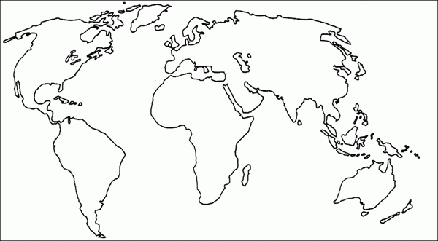
3. No one is allowed to go to the football game tonight Mom yelled harshly.
______________________________________________________________
______________________________________________________________
4. I think hesitated Tiffany I’d like to have a few more minutes on the test. ____________________________________________________________________________________________________________________________
5. John asked do you want to go steady _____________________________
______________________________________________________________
6. Today Mrs. Ashley told the class we are going to study the Columbian Exchange. _____________________________________________________
______________________________________________________________
7. The dumb redneck yelled hey y’all watch this. ______________________
______________________________________________________________

Cross-Curriculum & Miscellaneous
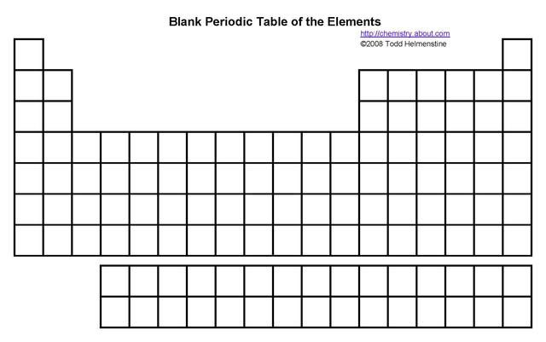
Science: correctly label fifteen boxes with their elements (use abbreviations); on own paper, write the elements next to abbreviations.

Social Studies: Annotate the Colombian Exchange and include what was traded.

