Name ______________________________________
Homework Paper #6
Due ____________

Reading Comprehension
There are Five Steps to Success for any reading passages:
1. Read the title, author, and any headings.
2. Read the first two questions.
3. Read and interact with the selection.
4. Ask yourself, “What was the main idea and the author’s purpose?”
5. Answer the questions using process of elimination.
Read the passage and answer the questions that follow.
Jackie Robinson #42
(1919-1972)
¶ Jackie Robinson’s interest in sports began early in his life. He attended college at UCLA and lettered in baseball and basketball, football and track. When Robinson, an African American, was growing up, sports teams were segregated. Black athletes and white athletes could not play together. Only white players were allowed to be on professional sports teams.
Jackie Robinson pioneered racial integration in professional sports. In 1947, he joined the Brooklyn Dodgers, a NY baseball team. Many fans were angry that an African American was on the team. Some wrote threatening letters; others mocked Robinson on the field. Some players didn’t want him on the team. But, he did not give up: he kept playing. He did so well in his first season that he was named Rookie of the Year.
In the ten years that Jackie Robinson played for the Dodgers, the team won six National League pennants and played in the World Series. Robinson retired in 1956, later raising money for the National Association for the Advancement of Colored People (NAACP) and speaking for the rights of African Americans. He also was elected to the Baseball Hall of Fame. Robinson broke the color barrier in major league baseball, which opened up the sports world to other African-American players.¶
1. Choose the best title for this passage.
A. Breaking the Color Barrier in Sports
B. A Great Baseball Player
C. Jackie Robinson’s College Years
D. Rookie of the Year
2. What is the best antonym for the word segregated in this selection?
A. isolated B. unified C. separated D. abbreviated
3. In which paragraph should the author place this quotation from Jackie Robinson: “A life is not important except in the impact it has on other lives”?
Paragraph 1 2 3
Justify your reasoning: ______________________________________________
_________________________________________________________________
4. The author’s purpose of this selection was most likely to . . .
A. To persuade readers to enjoy a baseball game
B. To inform readers that Jackie Robinson wore #42
C. To advise readers about a bellwether in the sports world
D. To criticize the American public of 1947
Classroom Connections
Circle the word that correctly completes each analogy (comparison of two things based on their relationship).
1. Stiff is to flexible as empty is to ___________.
A. low B. rigid C. full D. elastic
2. Glass is to transparent as wood is to ________.
A. clear B. opaque C. pine D. fragile
3. Waltz is to dance as oak is to _______.
A. acorn B. tree C. pine D. tango
4. Laugh is to tickle as shiver is to _______.
A. cold B. bored C. giggle D. amused

Writing and Grammar
Correctly label the points on a plot diagram and match up the definition of each term.

Climax Resolution Rising Action Exposition Falling Action
1) This is where the conflicts are resolved ______________________________
2) This is where we are introduced to characters, setting, and background information ______________________________
3) This is where characters reflect on whey they learned and make any changes __________________________
4) This is where conflicts are introduced and propel the story _________________
5) The highest point of intensity; all of the conflicts lead to this one dramatic moment ____________________________________
Label the following scenarios as either
Man v. Man Man v. Society Man v. Self Man v. Nature
1) A bright, cheerful person has difficulty assimilating into a classroom that is quiet and rigid. ___________________________________
2) Citizens in China decide to hold peaceful protests to bring awareness to unfair child labor practices. ___________________________
3). Your Myrtle Beach hotel is in a direct path of a tornado. ________________________
4) You are deciding whether to spring for a Bentley or save some money in a retirement account and buy a practical automobile. ___________________________
Cross-Curriculum & Miscellaneous
Science: Please write two equations and balance them for me.

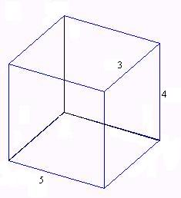

Math:
Find the volume of the following:
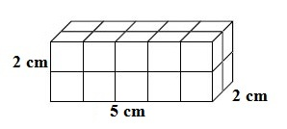

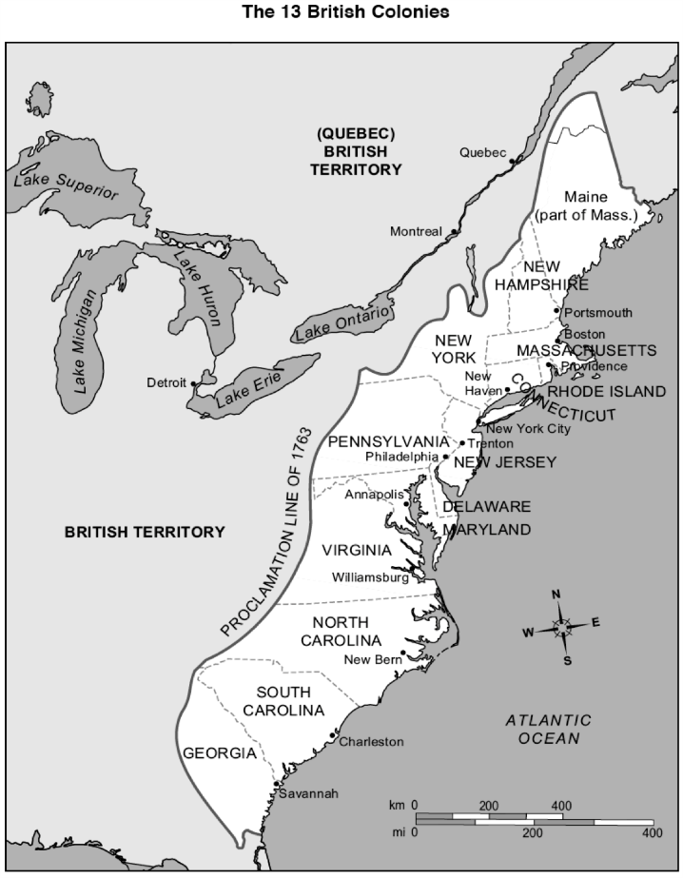
Social Studies: Color the New England, Middle, and Southern Colonies.

